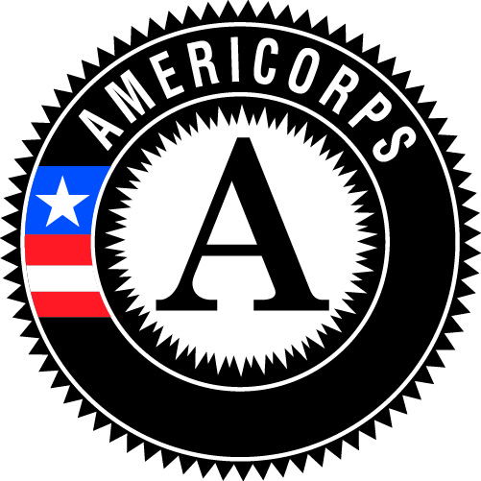
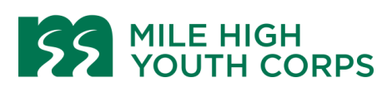
Energy and Water Conservation
Client Intake Corpsmember
**Driver’s License Required**

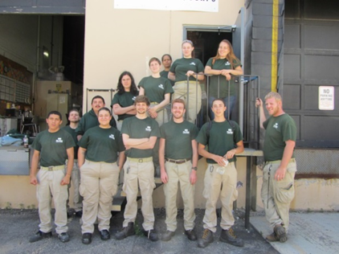
Position Description:

Energy and Water Conservation Corpsmembers will serve income qualified households in Metro Denver by installing energy and water saving measures (low-flow fixtures, programmable thermostats, and LED light bulbs) and educate our community about the importance of energy and water conservation. In addition, this position serves the community by providing support and assistance for emergent needs due to COVID-19 including health, infrastructure, environmental and social issues. Embedded within MHYC’s Energy and Water Conservation program, Corpsmembers will engage in an intensive program that offers leadership development, technical skill-building, career readiness training and an opportunity to serve your community with a diverse crew. MHYC supports Corpsmembers as they explore their future goals and career pathways.
- The Client Intake Corpsmember assists successful project implementation by conducting outreach to community members, scheduling Energy and Water Conservation assessments, and assisting with program reporting to program partners.

Corpsmembers EARN:
- Biweekly stipend: Earn a living stipend of $840 before taxes every two weeks. There is a potential for a performance-based raise.
- AmeriCorps Education Award: Earn a scholarship of $4336.50 upon successful completion of a 1200 hour term of service. This award can be used to pay education related costs including tuition and payback qualifying student loans. Individuals have 7 years to use the education award.
Timeline:
This is a temporary position. The 1200 hour term will run January 13 – September, 3, 2021.
- 1200 hours of service in a 8-month commitment
- Mon-Thurs 8 a.m. – 4:30p.m., Fridays 8a.m. – 4p.m. Schedule may vary depending on project needs.
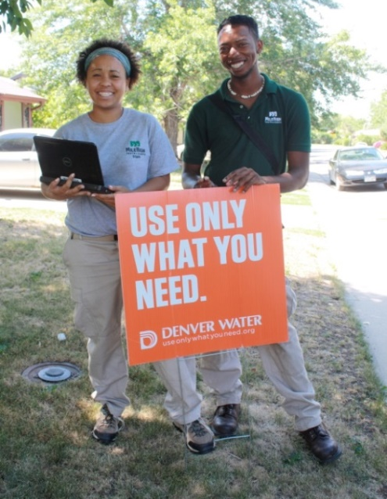
Corpsmembers SERVE:
- The Community: Provide assistance and support in COVID-19 community response and recovery efforts, and in service projects and Global Youth Services Days that support local nonprofits and our community.
- Income-qualified clients: Help clients reduce their utility bills by installing high efficiency fixtures in their homes. You also offer information on energy and water conservation techniques.

Corpsmembers RECEIVE:
- Trainings: Hands-on technical training related to all projects and tools, leadership development, civic engagement, interacting with diverse clients, customer service, Career and College Readiness, and educational opportunities through our community partners. Our team also receives industry-recognized trainings that can help secure future employment such as OSHA-10, First-Aid/CPR, and others.
- Career advancement: Connect with professionals in conservation careers and have an opportunity to develop your career pathway.
- Leadership Opportunities: Opportunities for peer leadership include serving on the Leadership Council, developing service projects, supporting client intake, and delivering environmental education, civic engagement, and service learning activities. Corpsmembers also have the opportunity to provide direct programmatic input and direction in leadership roles.
- Student loan forbearance: Possible through the National Service Trust on qualifying federal government student loans.
- Health Insurance: May be eligible for health insurance the 1st of the month after serving at MHYC for sixty days. Member will have a share of health the monthly insurance premium.

Qualifications:
MHYC is committed to hiring candidates with unique backgrounds and perspectives. If you are interested in this job but are concerned that you do not meet all of the requirements or possess all of the necessary skills, or that prior convictions or your background might disqualify you, we encourage you to submit an application anyway.

- Between 21-24 years old. Must be eligible for enrollment in AmeriCorps as a US Citizen, National, or Lawful Permanent Resident. Documentation will be required on the first day.
- Valid driver’s license with insurable driving record needed.
- Ability to learn and retain knowledge on energy and water conservation and teach others.
- Superior people skills, including excellent communication and writing skills with a strong attention to detail.
- Bilingual candidates (Spanish and English) preferred. Desire and ability to engage with people from different backgrounds and demographics.
- Proficiency with computer productivity software including Microsoft Office and Google Docs.
- Customer service and data management experience.
- High School Diploma or GED required.
- Capable of participating in physical labor including but not limited to: ability to lift 50 lbs., able to conduct repetitive hand and arm motions, and able to maneuver in tight spaces, including bending and kneeling. Reasonable accommodations will be made in compliance with the Americans with Disabilities Act.
- Desire and ability to engage with people from different backgrounds and demographics.
- Responsibly serve in clients homes and represent MHYC positively at all times.
- Able to commit to the whole term of service.
Requirements:
- This position has recurring access to vulnerable populations and therefore candidates must complete a pre-service background check which includes fingerprinting.
- Pre-service drug screen required. Drug testing may be required during the term.
- Must not engage in any prohibited activities listed in the AmeriCorps member service agreement and must adhere to rules and regulations specified in the MHYC handbook.
- Fully comply with agency policies and procedures regarding high quality service, installations, tool management, paperwork completion and data accuracy.
- This position reports to Project Manager: Energy and Water Conservation.
To Apply:
Visit our website at www.milehighyouthcorps.org and click “Apply Now”. Or visit us in person at 1801 Federal Blvd, Denver, CO 80204. Questions? Email youthjobs@mhyc.net or call 303-433-1206 x221.
Mile High Youth Corps (MHYC) is an Equal Opportunity Employer. MHYC is committed to diversity in principle and practice, both in the community at large and within the organization. We are, therefore, committed to having our internal operations and employment practices administered on a non-discriminating basis inclusive of, but not limited to, race, religion, color, socio-economic status, gender, age, sexual orientation, military or veteran status, physical or mental disability, marital status, or national origin. Every effort shall be made to grant reasonable accommodation for qualified people with disabilities to participate in this AmeriCorps program.

