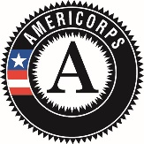
Energy and Water Conservation Corpsmember

Position Description:

Energy and Water Conservation Corpsmembers will serve income qualifying households in Metro Denver by installing energy and water saving measures (low-flow fixtures, programmable thermostats, and LED light bulbs) and educate our community about the importance of energy and water conservation. In addition, this position serves the community by providing support and assistance for emergent needs due to COVID-19 including health, infrastructure, environmental and social issues. Embedded within MHYC’s Energy and Water Conservation program, Corpsmembers will engage in an intensive program that offers leadership development, technical skill-building, career readiness training and an opportunity to serve your community with a diverse crew. MHYC supports Corpsmembers as they explore their future goals and career pathways.

You EARN:
- Biweekly stipend: Earn a living stipend of $800 before taxes every two weeks.
- AmeriCorps Education Award: Earn a scholarship of $4,336.50 upon successful completion of a 1200-hour term of service. This award can be used to pay education-related costs including tuition and payback of qualifying student loans. Individuals have 7 years to use the education award.
Timeline:
This is a temporary position. The 1200 hour term will run January 18 – September, 3, 2021.
- 39.5 hour weeks, Mon-Thurs 8:00 a.m. – 4:30 p.m., Fridays 8 a.m. – 4 p.m. Schedule may vary depending on project needs.
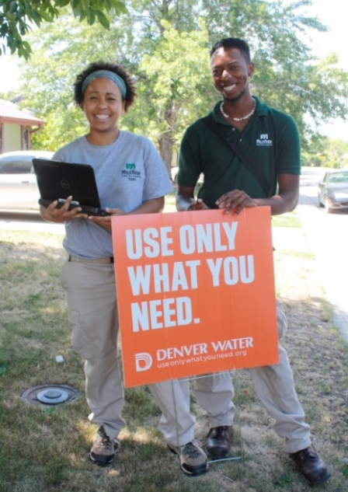
- Certain project opportunities may require temporary suspension from AmeriCorps terms of service due to professional development, Career Readiness Training, and/or mentorship opportunities in the energy and water field. The suspension will not last longer than four (4) weeks and Corpsmembers will not accrue AmeriCorps hours or stipend during the period of suspension. However, Corpsmembers will be compensated during this time. Corpsmembers will be reinstated to their service term immediately following such projects and resume earning the living stipend and hours. These opportunities may potentially result in extending the required term from the dates above to complete requirements.

You SERVE:
- The Community: Provide assistance and support in COVID-19 community response and recovery efforts, and in service projects and Global Youth Service Days that support local non-profits and our community.
- Income-qualified clients: Help clients reduce their utility bills by installing high-efficiency fixtures in their homes. You also offer information on energy and water conservation techniques.

You RECEIVE:
- Trainings: Hands-on technical training related to all projects and tools, leadership development, civic engagement, interacting with diverse clients, customer service, Career and College Readiness, and educational opportunities through our community partners. Our team also receives industry-recognized trainings that can help secure future employment such as OSHA-10, First-Aid/CPR, and others.
- Career Advancement: Connect with professionals in conservation careers and have an opportunity to develop your career pathway.
- Leadership Opportunities: Opportunities for peer leadership delivering environmental education, civic engagement, and service learning activities. You also have the opportunity to provide direct programmatic input and direction in leadership roles.
- Health Insurance: May be eligible for health insurance the 1st of the month after serving at MHYC for sixty days. Member will have a share of health the monthly insurance premium.
- Student Loan Forbearance: Possible through the National Service Trust on qualifying federal government student loans.
Qualifications:
MHYC is committed to hiring candidates with unique backgrounds and perspectives. If you are interested in this job but are concerned that you do not meet all of the requirements or possess all of the necessary skills, or that prior convictions or your background might disqualify you, we encourage you to submit an application anyway.
- Between 18-24 years old. Must be eligible for enrollment in AmeriCorps as a US Citizen, National, or Lawful Permanent Resident. Documentation will be required on the first day.
- High School Diploma or GED required.
- English proficiency; bi-lingual Spanish speaking applicants encouraged to apply.
- Capable of participating in physical labor including but not limited to: ability to lift 50 lbs., able to conduct repetitive hand and arm motions, and able to maneuver in tight spaces, including bending and kneeling. Reasonable accommodations will be made in compliance with the Americans with Disabilities Act.
- Desire and ability to engage with people from different backgrounds and demographics.
- Demonstrate commitment to serving with your team, communication and problem solving.

Requirements:
- This program requires some CM positions to be program drivers; driver eligibility requirements: minimum 21 years old, valid driver’s license, and insurable DMV record.
- This position has recurring access to vulnerable populations and therefore must complete a pre-service background check which includes fingerprinting.
- Pre-service drug screen required. Drug testing may be required during the term.
- Must not engage in any prohibited activities listed in the AmeriCorps member service agreement and must adhere to rules and regulations specified in the MHYC handbook.
- Fully comply with organization policies and procedures.
- This position reports to Program Coordinator: Energy and Water Conservation.
To Apply:
Visit our website at www.milehighyouthcorps.org and click “Apply Now”. Or visit us in person at 1801 Federal Blvd, Denver, CO 80204. Questions? Email youthjobs@mhyc.net or call 303-433-1206 x 221

Mile High Youth Corps is committed to diversity in principle and practice, both in the community at large and within the organization. We are, therefore, committed to having our internal operations and employment practices administered on a non-discriminating basis inclusive of, but not limited to, race, religion, color, socio-economic status, gender, age, sexual orientation, military or veteran status, physical or mental disability, marital status, or national origin. Every effort shall be made to grant reasonable accommodation for qualified people with disabilities to participate in this AmeriCorps program.

